IT6034 Game Development

Project: Speedy Demon Racer

Nicholas Richard Harding

  20200344

# Page 1: Cover Page

Speedy Demon

Racer

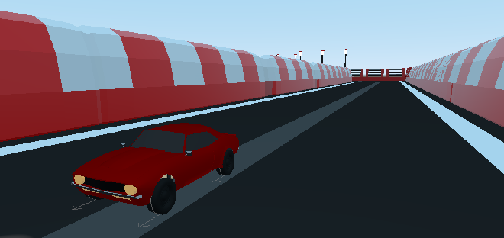

Design By Nicholas R. Harding

Date: 04/07/2021

Ages: 10+

Ship Date TBD

Table of Contents

Page 1: Cover Page 1

Page 2: Story/Game Summary 2

Page 3: Character(s) and Controls 3

Page 4: Gameplay Overview 4

Page 6: Gameplay Experience 6

Page 7: Mechanics and Modes 7

Page 8: Enemies and Bosses 8

Page 9: Bonus Material, and Downloadable Content and Monetization 9

# Page 2: Story/Game Summary

Story

Is based about a demon trying to be the absolute best progressing through one race at a time (level by level)

Beginning: Player starts with the ability to jump straight into the game and start on level 1 or view the tutorial to explain how this game works.

Middle: Player will have progressed halfway through the game levels

End: the player has completed all levels and is now ruler of the underworld allowing benefits to the player such as new vehicles and in later releases access to maps for players who have completed the game.

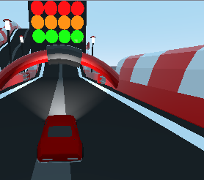

# Page 3: Character(s) and Controls

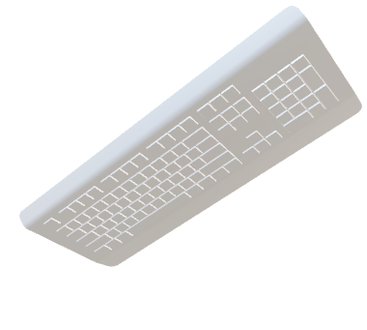The player controls the demon called “underdog”, who is competing against other demons for the right to rule. Underdog must keep constantly moving to maintain his edge against his opponents, if the player does not keep progressing to the next checkpoint the player loses.

Physical controls for the player:

Forwards: **W** key or **RT** on a gamepad.

Backwards: **S** key or **LT** on a gamepad.

Left: **A** key or **LeftAnalog Stick in the left direction** on a gamepad.

Right: **D** key or **LeftAnalog Stick in the right direction** on a gamepad.

Brake: **Space** key or **B** button on the gamepad.

Pause Menu: **ESC** or **start** on a gamepad.

Extra controls when game is paused, victory and game over

Quit: **Q** key and **B** on the gamepad

Continue: **Enter** key and **A** button on gamepad

Open sound menu: **Tab** key and **Back** button on gamepad

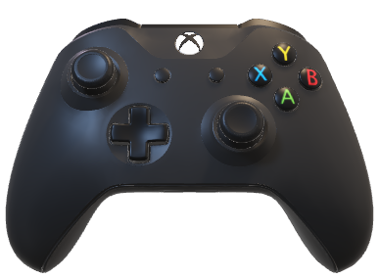

# Page 4: Gameplay Overview

The game genre for this game is racing. The player controls a demon that must go round a track and reach checkpoints throughout the track to keep the player moving and under pressure, will make the game more difficult for the player as this can make the player take parts of the track faster than what is appropriate and cause the player to roll or fall off the track making the player loose. If they go too slow this will also cause the player to fail.

All the tracks are currently created by the developer designing and placing the tiles themselves, this is because the maps are fixed and do not change allowing a greater placement of the pickups that can make the levels harder on the player.

There consist pickups of positive and negative effects on the player and course.

**Positive Effects:**

|  |  |  |
| --- | --- | --- |
| **Effect Name** | **Image** | **Effect Type** |
| Repair Car |  | **Positive** |
| Rocket Booster |  | **Positive** |
| Repair Tunnel Collapse |  | **Positive** |
| Bomb |  | **Negative** |
| Collapse Tunnel |  | **Negative** |

The game allows for the user to be able to choose which level they play if they have completed the level before and completed successfully, the player can replay completed levels if they choose to in the main menu.

Once the player has completed the game more features will appear in the menu one being choosing different vehicles to drive, by doing this it will keep the player on the game and to replay the game.

# Page 6: Gameplay Experience

The objective for the games experience is to make the player constantly feel under pressure, this keeps the player moving and on occasion make mistakes due to the pressure. By making the players under pressure it will trigger the adrenaline feeling, this is important as if the adrenaline is up the more excited a player will be about a game and perceive it to be more entertaining. This experience also plays on the other side of the game and that is the frustration and challenge aspect of it. The game is designed to be a little unforgiving and means that when players are under pressure, they are likely to make mistakes and run into one of the games lose conditions. A common lose condition that the players will run into is time out and contact with lava, these conditions can occur from being stuck in fence gaps, coming off the track and collapsed tunnels. By making the experience challenging and slightly frustrating will make the game enjoyable in the sense that its not too easy to win and a sense of satisfaction when the challenge is overcome.

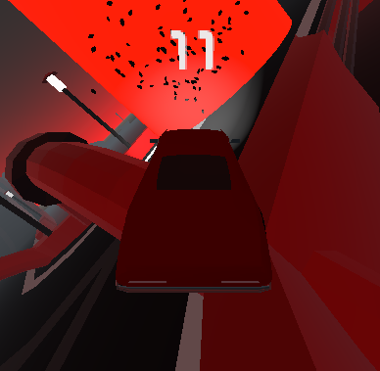

# Page 7: Mechanics and Modes

Positive Effects:

* Repair Car – the repair car pickup is in the shape of a spanner that the player can drive through and fix the car to 100%.
* Rocket Booster – the rocket booster is in the shape of a rocket and upon pickup is attached to the car allowing greater acceleration and top speed.
* Repair Tunnel Collapse – the repair tunnel collapse is in the shape of a blue shield, what this does is if the collapse tunnel pickup has been picked up then the tunnels on the map will begin to repair and grow the tunnel shields to default size.

Negative Effects:

* Bomb - the bomb pickup is in the shape of a bomb with a lit fuse, when the player drives over it causes an explosion and a car part falling off and smoke to start billowing out of the car in the area that has been affected, if the player drives through too many bombs without repairing the car, they will die, and the car blow up causing a loose situation
* Collapse Tunnel – the collapse tunnel looks like the repair tunnel collapse with the only difference being that the shield is red. This causes the tunnel to slowly collapse and shrink the tunnel to nothing, if the player does not repair it in time or before they get to the tunnel, they will lose the game as they will not be able to get across the lava.

# Page 8: Enemies and Bosses

In this prototype there are no enemies or bosses, however in the actual game there will be, the enemies will consist of a variety of different vehicles. Like the player they too will be able to pick up the boosters and possibly the negative ones too but picking up the negative ones would have to be trialed because it may have on the gameplay if they kept collapsing the tunnels all the time. Currently there will be no bosses.

The enemies will be scripted in such a manner that if a player is behind them then they will try to block them from passing and ram them if it is not too hard on the players to win.

# Page 9: Bonus Material, and Downloadable Content and Monetization

Throughout the game as the player progresses, they will unlock new levels and be able to replay all levels.

As part of future updates, they will be able to download extra content, such as levels, vehicles and music.

These downloadable features will be a combination of free and purchases. By making a combination of free and purchasable content will keep the players interested to keep playing the game for longer durations.

